PROJECT REPORT

(Submitted for the Degree of B.Com. Honours in

Accounting & Finance under the University of

Calcutta)

TITLE OF THE PROJECT:

“E-COMMERCE”

SUBMITTED BY

Name of the Candidate : RAVI KANT BHALOTIA

Registration Number: 988-303-4569

Name of the College: THE BHAWANIPUIR EDUCATION

SOCIETY COLLEGE

College Roll Number: 123

CU exam Roll Number: 8820-69-6761

SUPERVISED BY

Name of the Supervisor: DR. ALKA BHALOTIA

Name of the College: THE BHAWANIPUIR EDUCATION

SOCIETY COLLEGE

MONTH & YEAR OF SUBMISSION:

Date: June, 2021

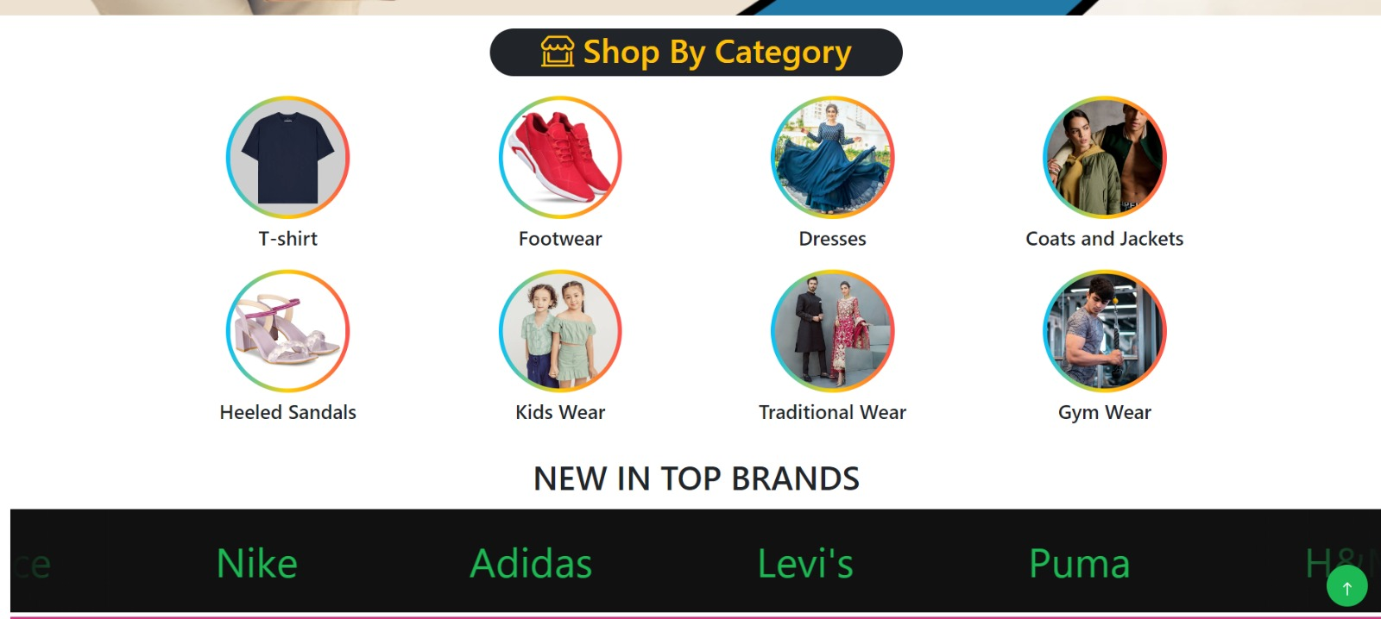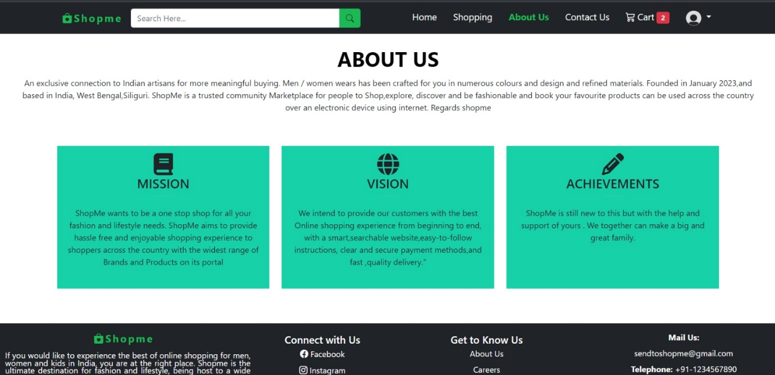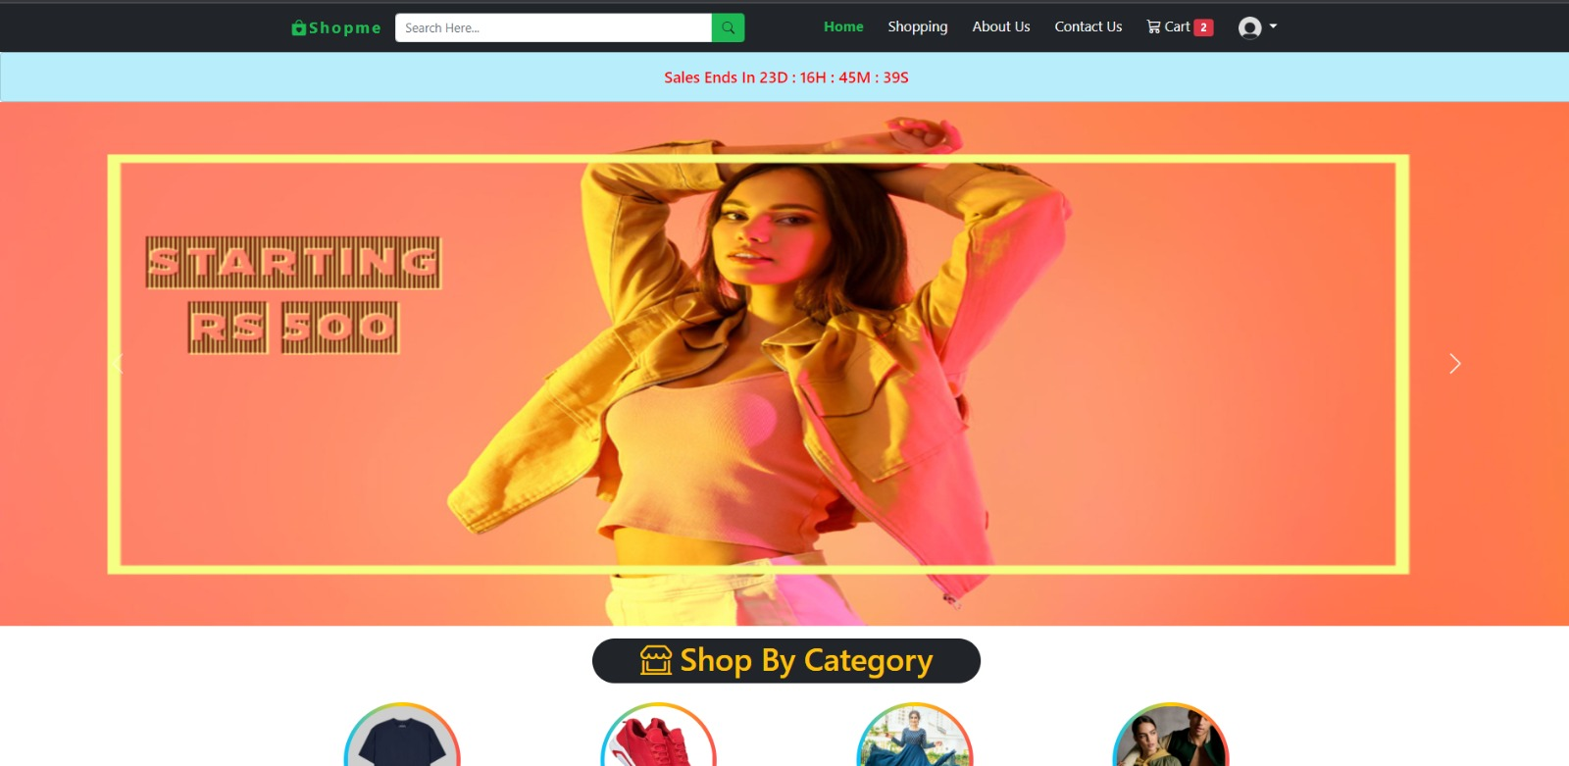**GUI DESIGN**

**5.1 MODULES:**

The system after careful analysis has been identified to be presented with the following modules and roles.

The modules involved are:

* User
* Administrator

**5.1.1 USER:**

* Registration
* Login
* View products
* Search Products
* Add to Cart
* Coupon
* Order Summery and Payment
* Email Verification
* Orders
* Invoice
* Track Order
* User Profile
* Coupon
* Change Password
* Contact Us

**Step 1: Sign Up / Registration –**

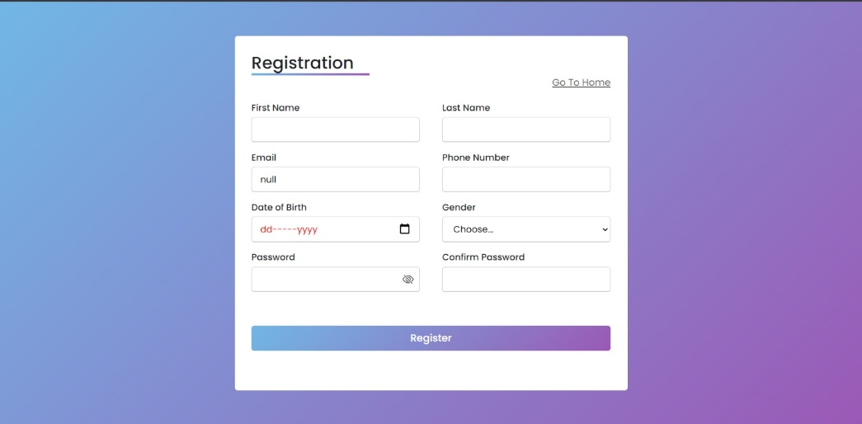

**The First step requires your credentials Such as -**

1. First Name
2. Last Name
3. Email
4. Phone Number
5. Date Of Birth
6. Gender
7. Password

**\*\*If any of the fields are not entered the message displays as\*\***

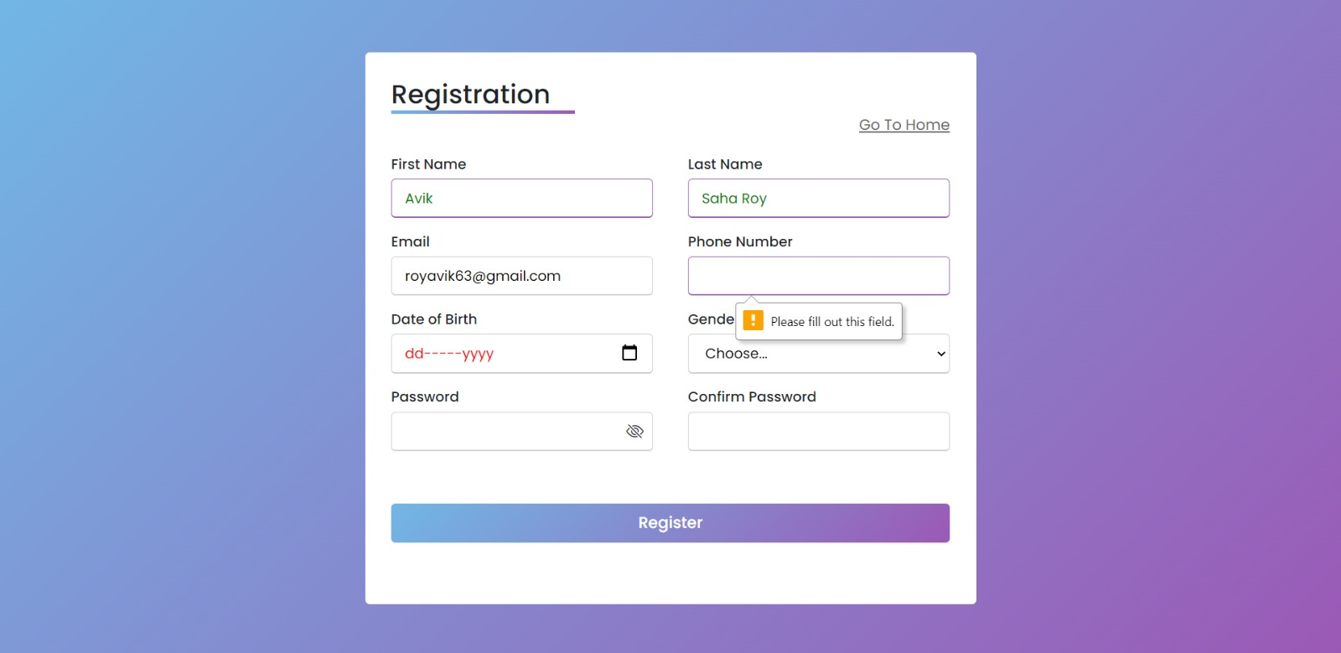

So, until and unless you fill all your credentials you won’t be able to go next step.

**Step2: Login –**

If the user/ customer already has an account then the customer can simply put their Registered Email and the password and successfully login to their own account.

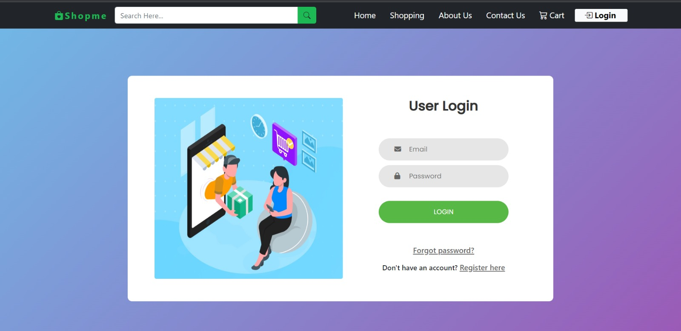

**After a Successful Signup You can now browse the Products you wish to –**

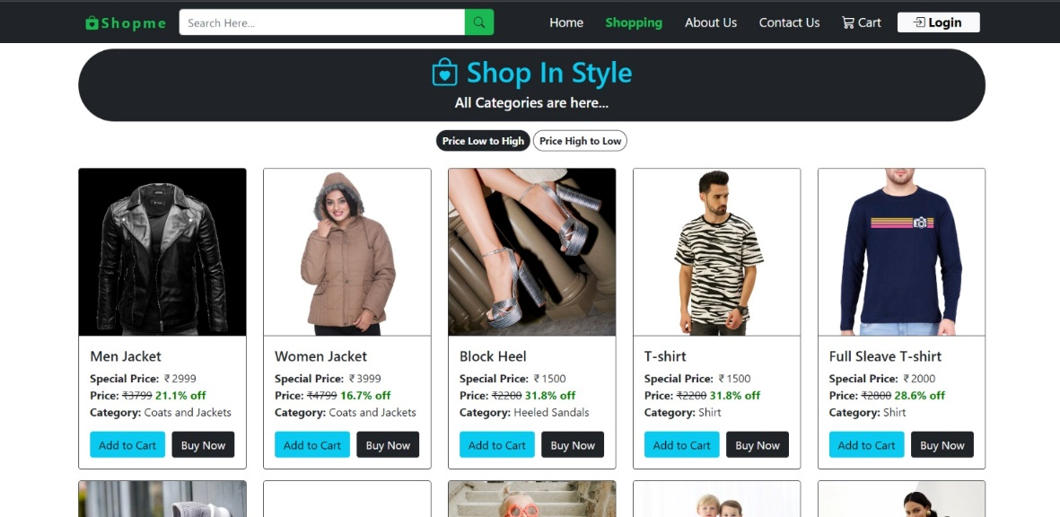

**\*\*How to buy the products at ShopMe.com? \*\***

**Step 1: Search the product in the search bar option.**

For example, you want to buy a kurti. So go to the search bar option search for kurti and the website shows you the kurti’s that are available.

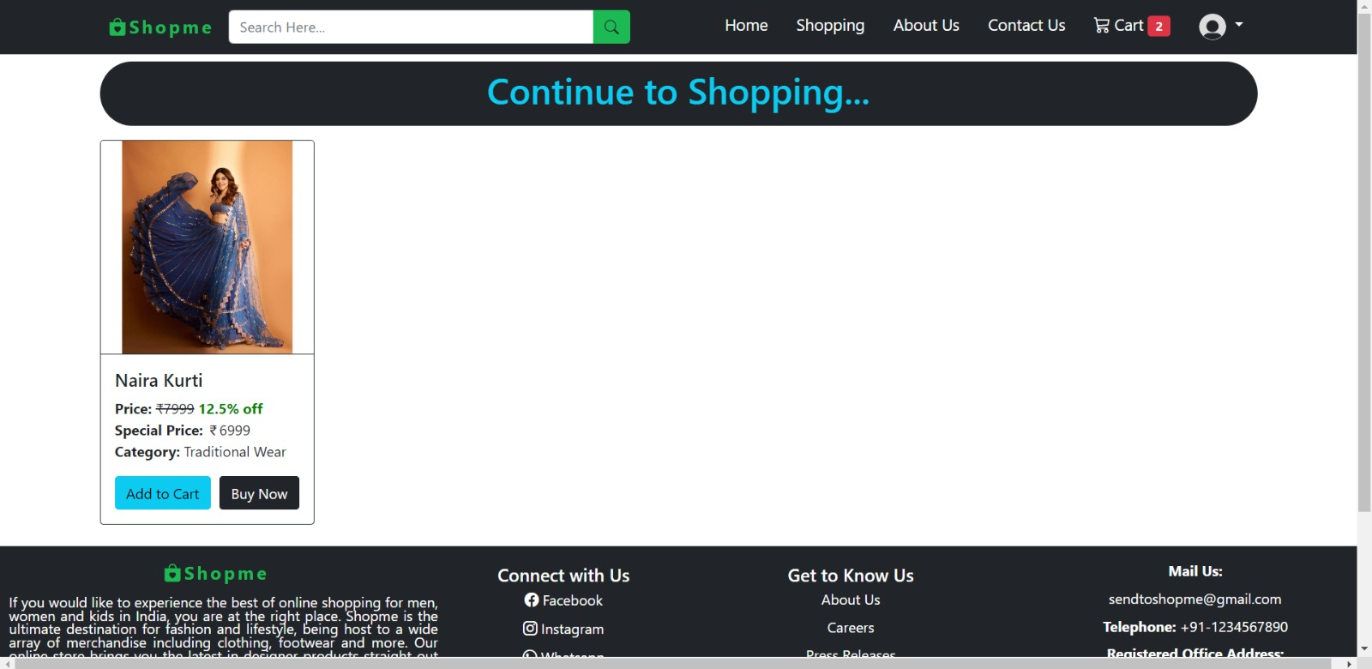

**Step 2: The Cart menu**

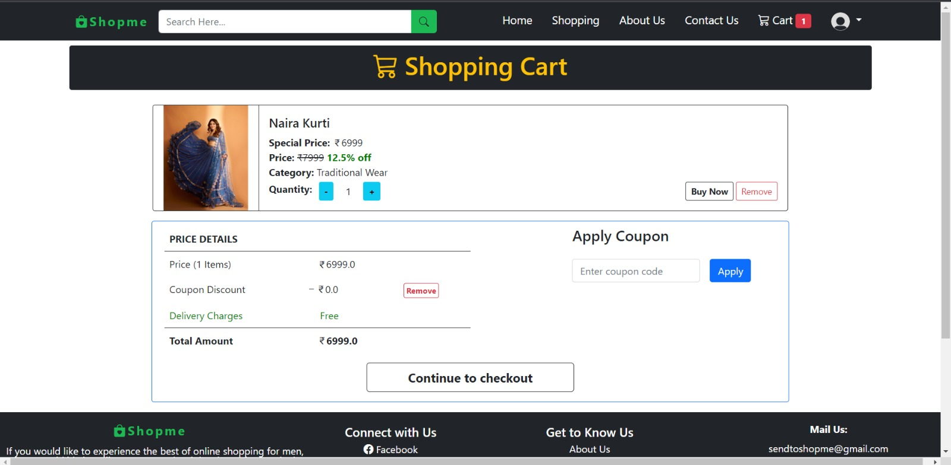

**Step 3: Coupon (Optional)**

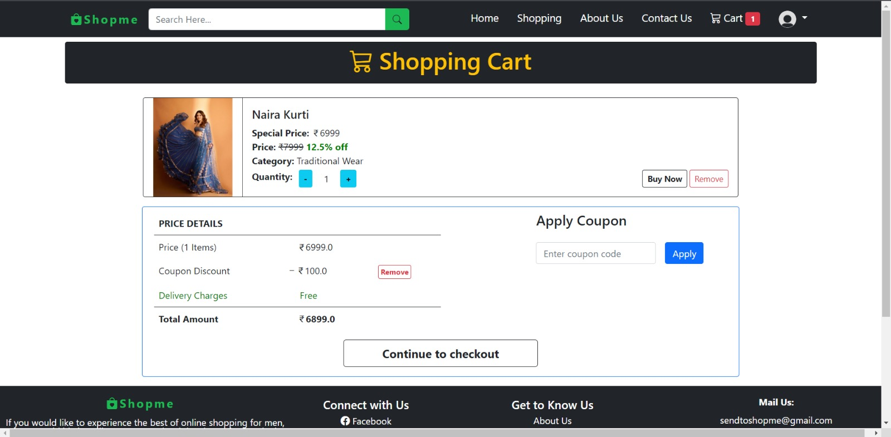

**Step 4: After clicking on “CONTINUE TO CHECKOUT”. You get The Address page.**

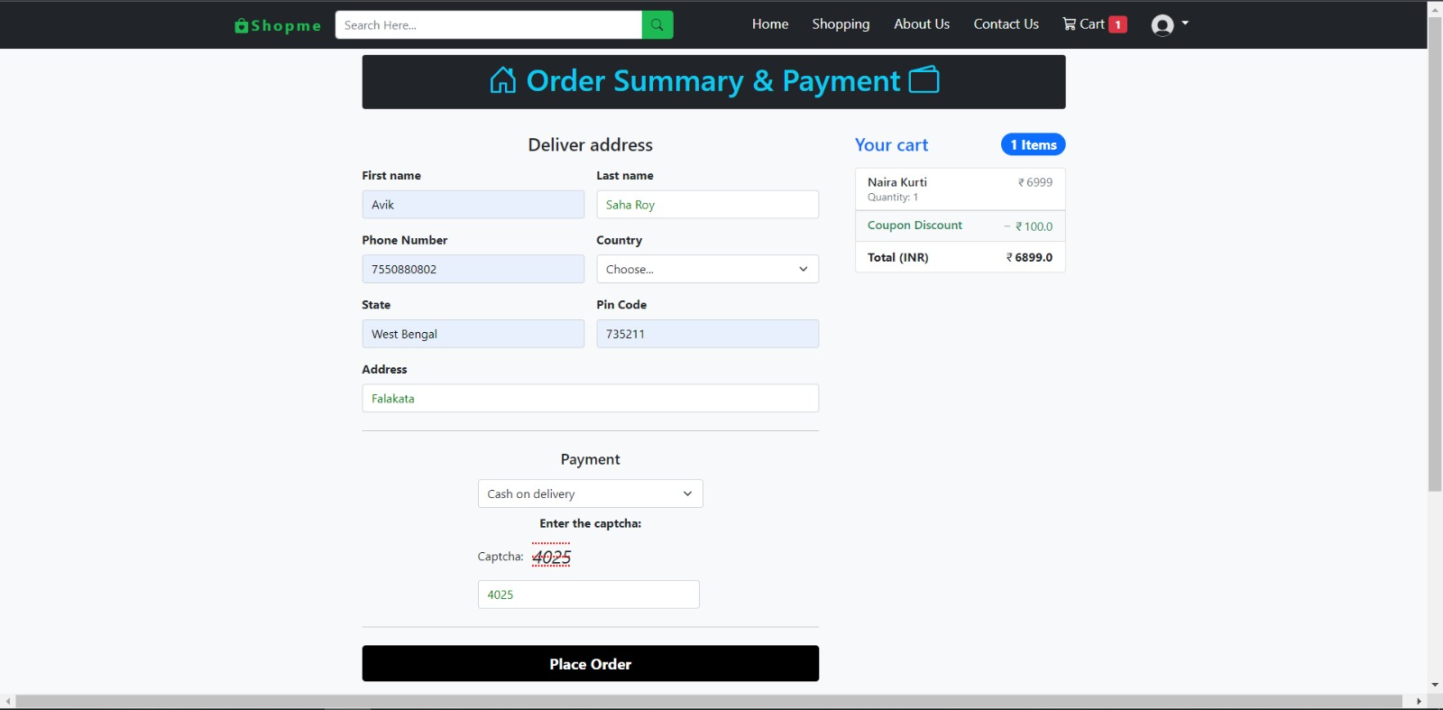

**Step 5: Payment Option. For payment option we initially have two options available i.e., so the customer can choose any:**

1. Cash On Delivery
2. UPI

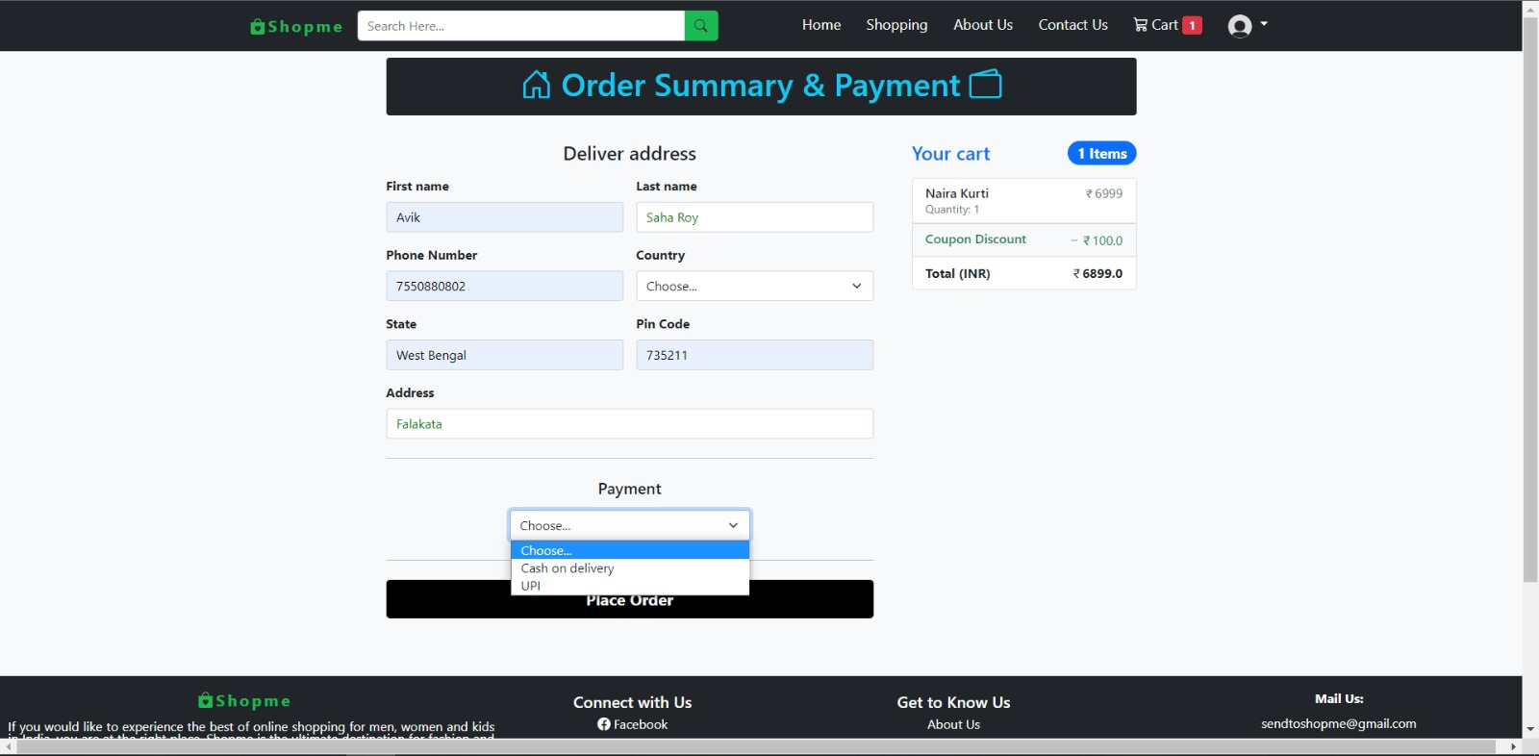

**Step 6: Last and final option “Place Order”. Your Order gets placed successfully.**

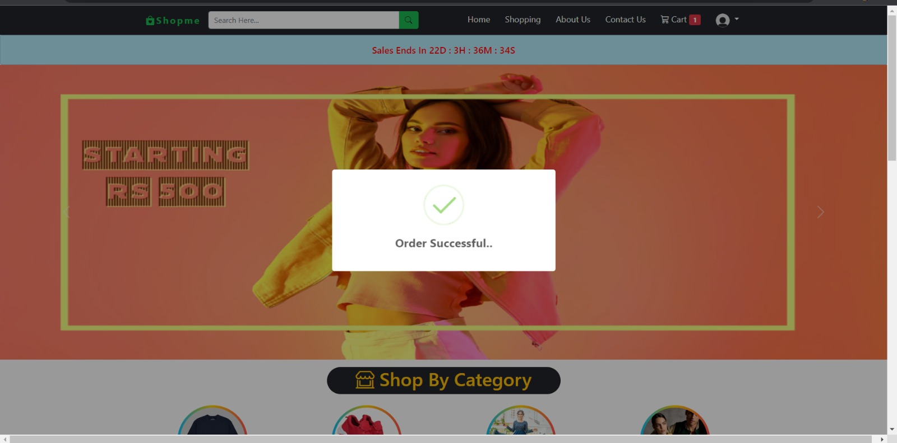

**Email Verification:**

Now if the customer forgets his/ her password then by clicking on the forgot password option he/she can change the password.

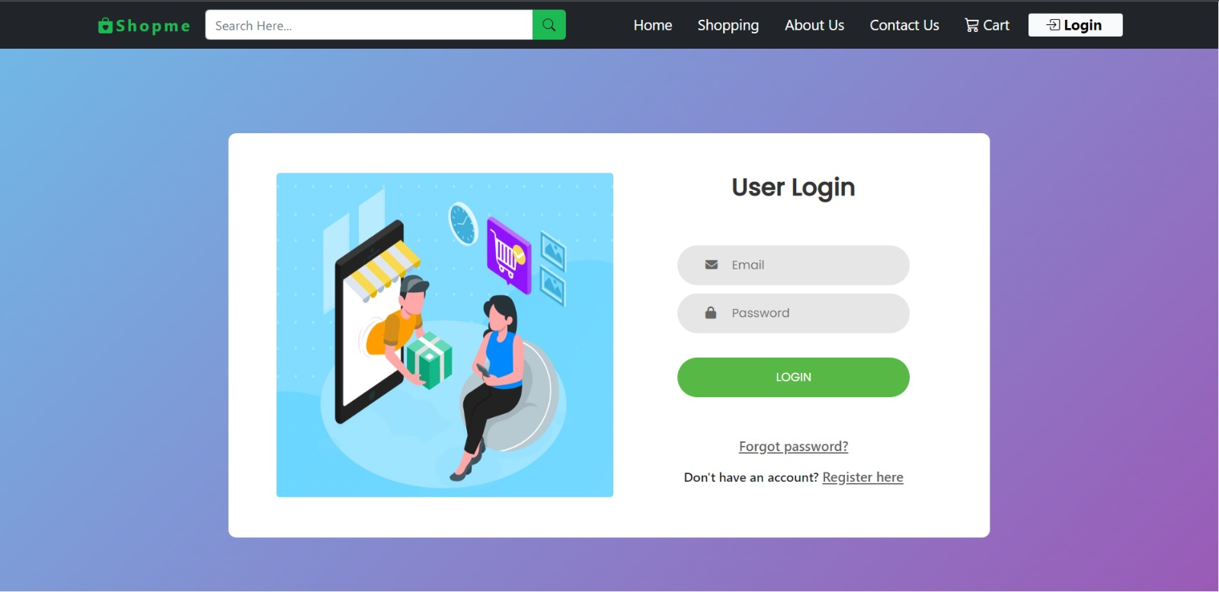

1. **Verification Code :** First put your Email and click on send OTP

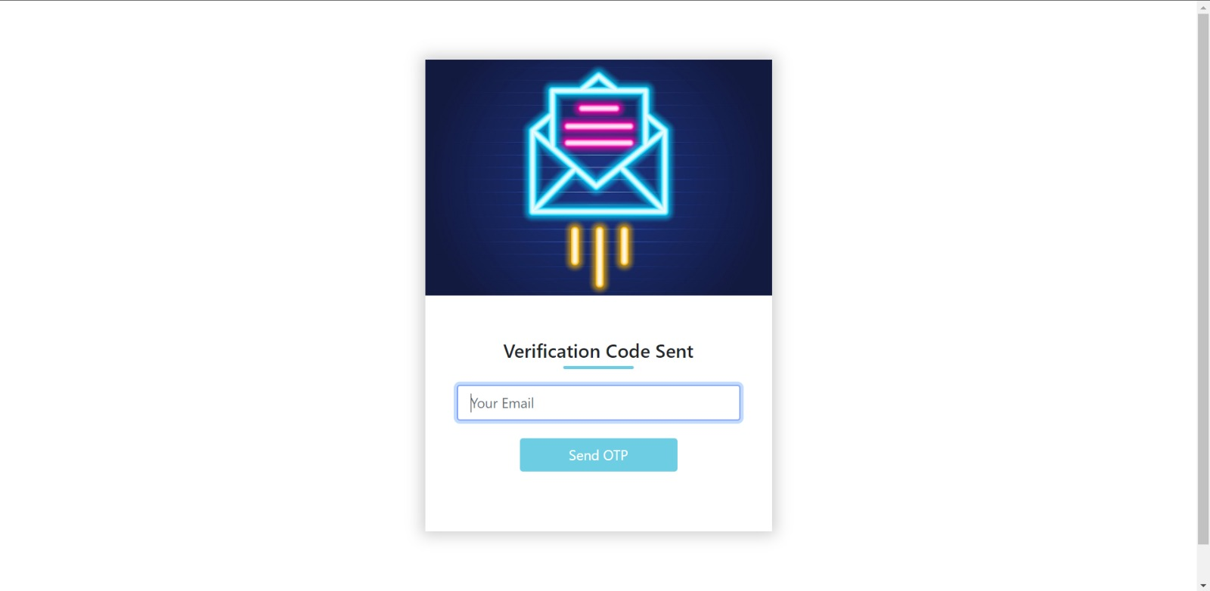

1. **Enter the OTP sent to your email.**

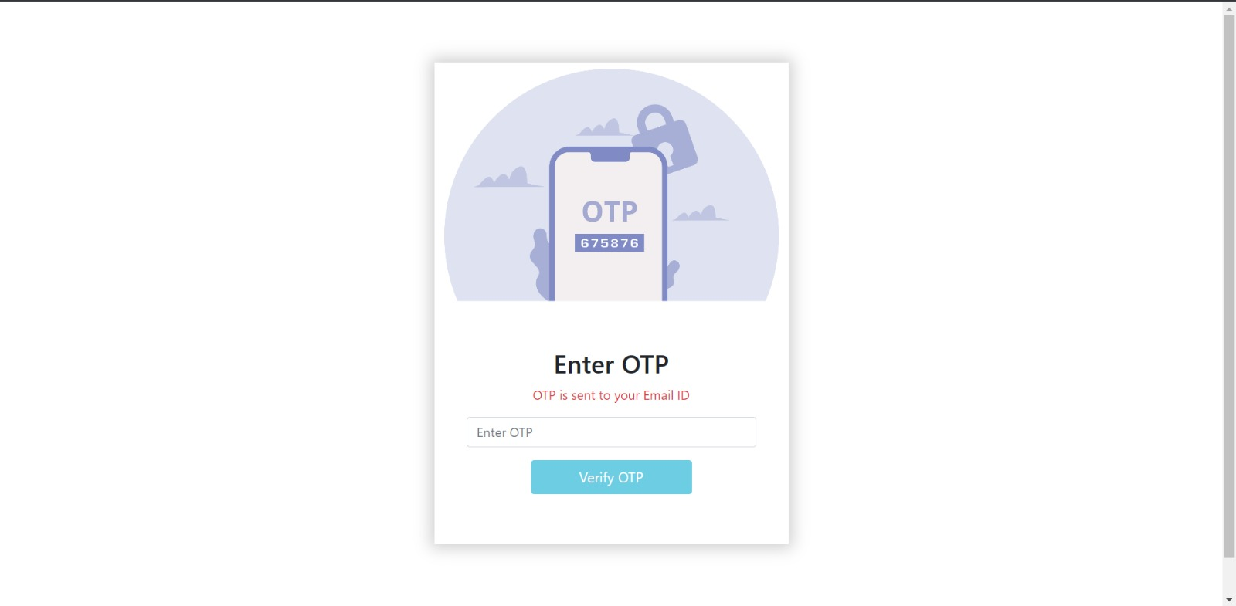

1. **Then simply change your password and click on Reset.**

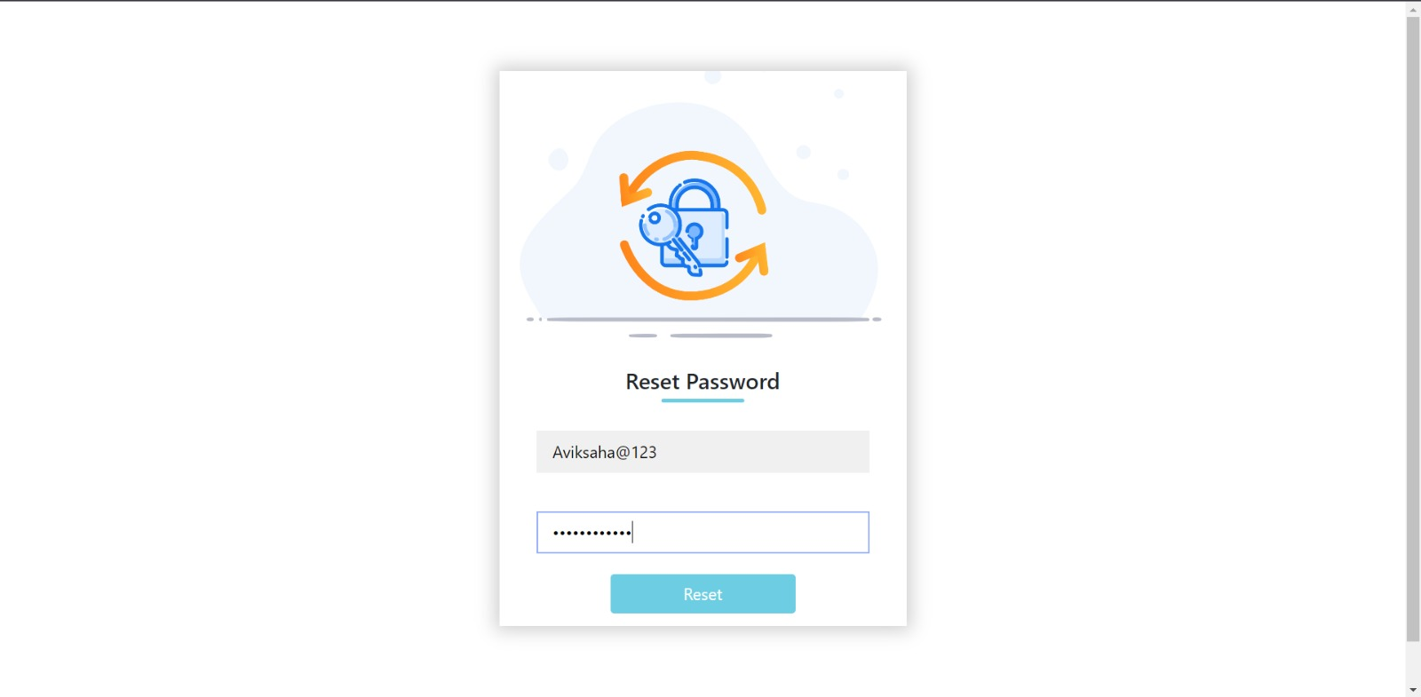

**My Orders:**

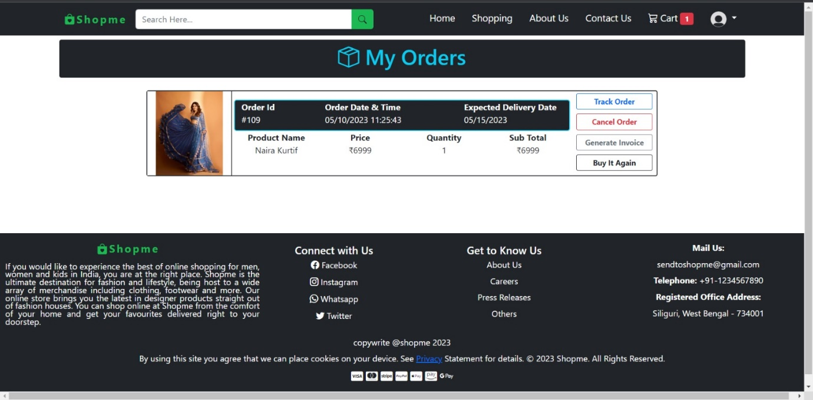

**Invoice:**

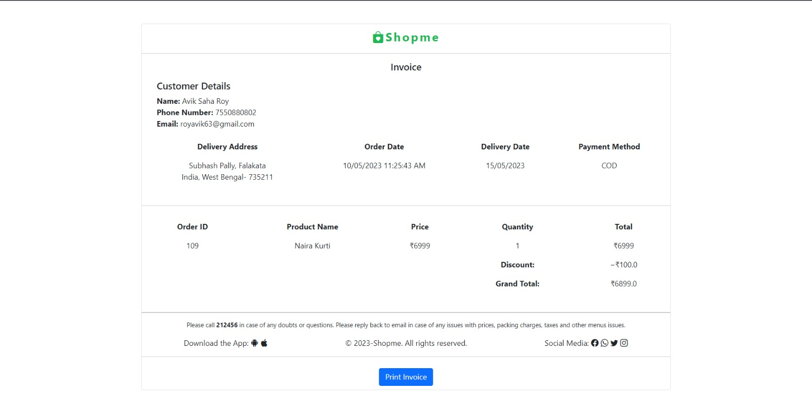

**Track Your Order:**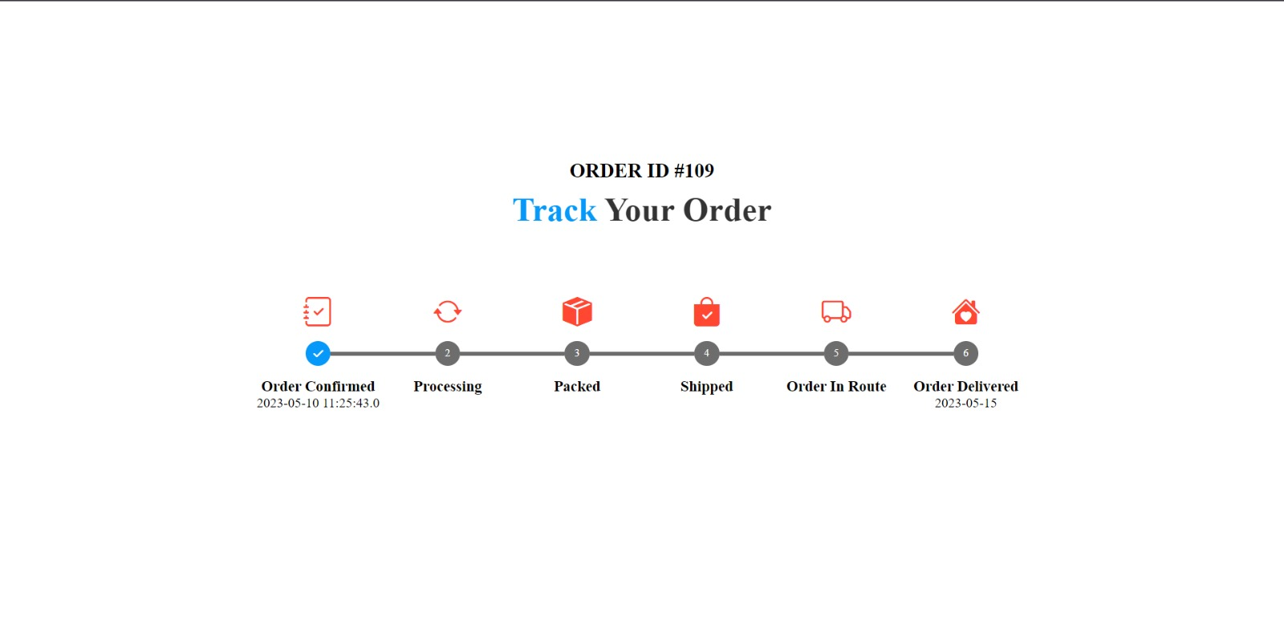

**User Profile:**

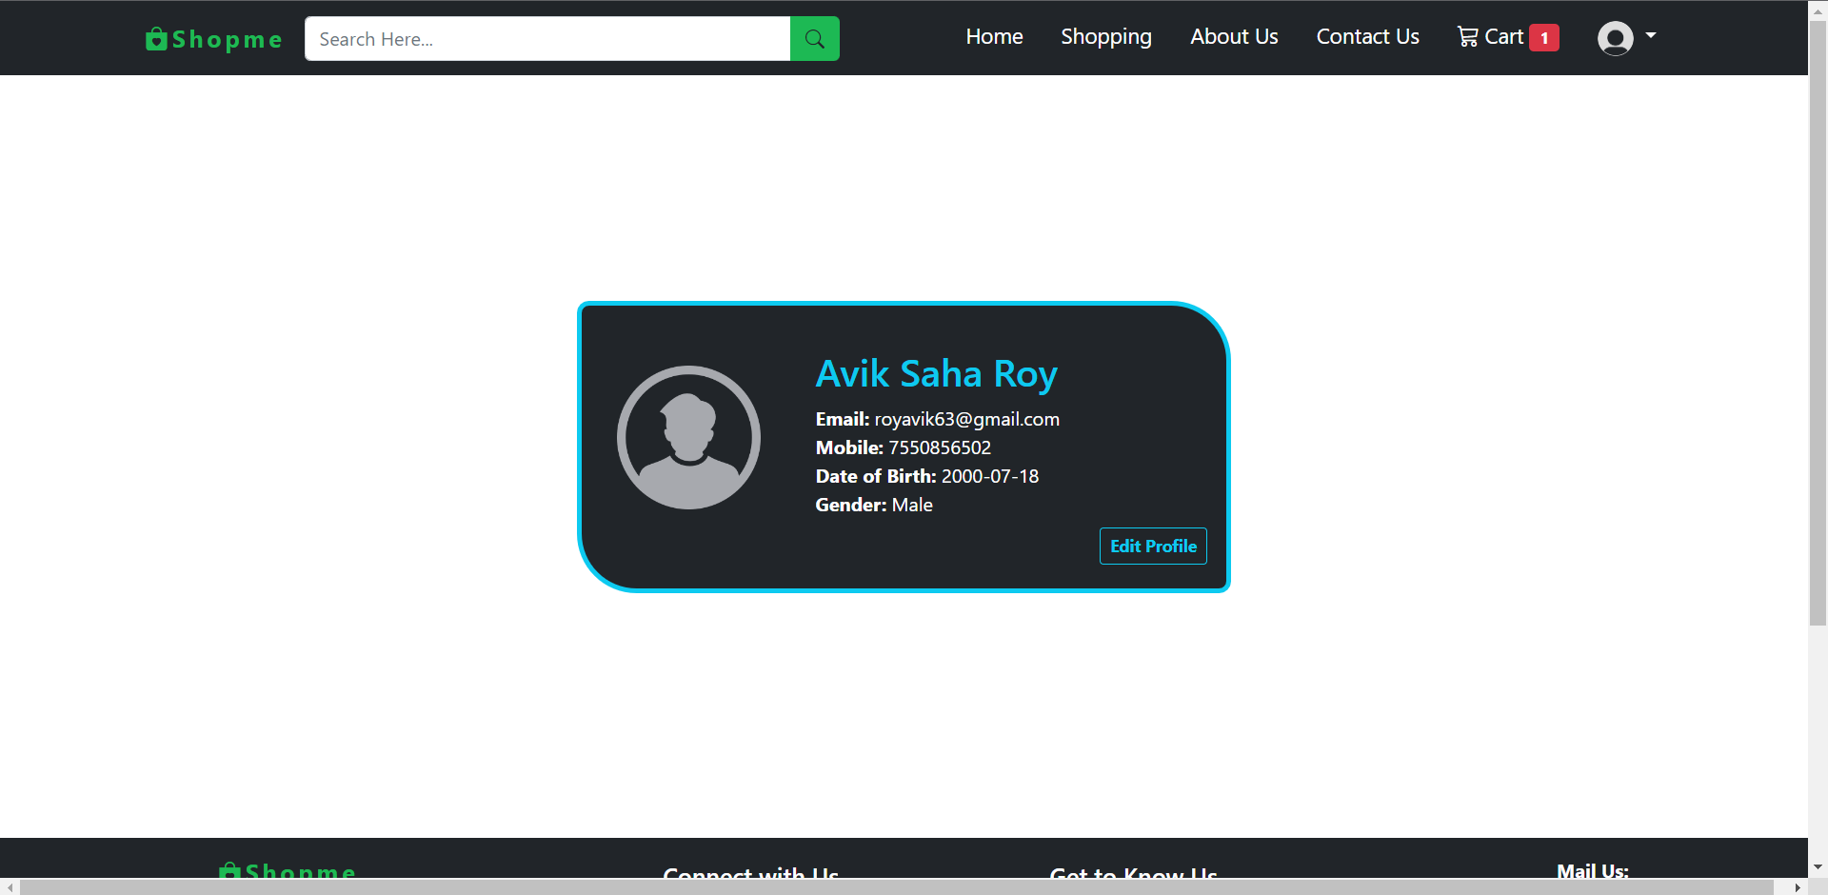

**My Coupon:**

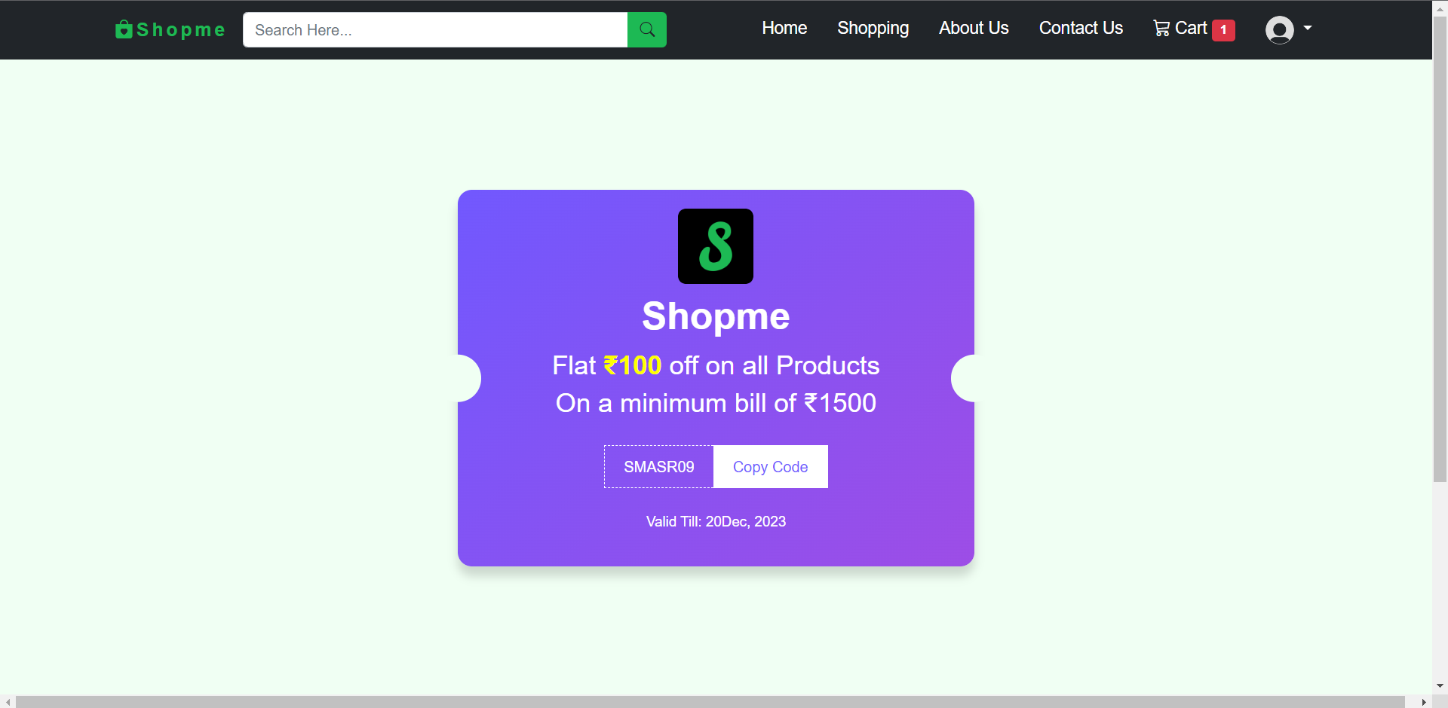

**Change Password:**

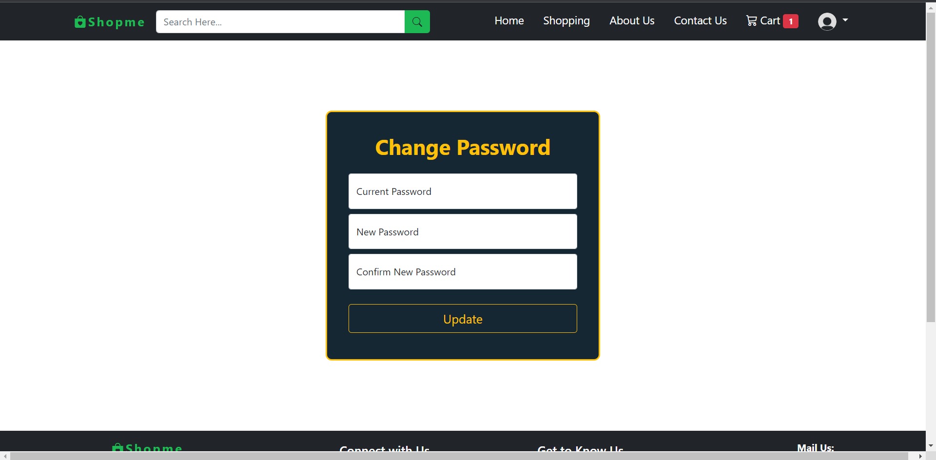

**Contact Us:**

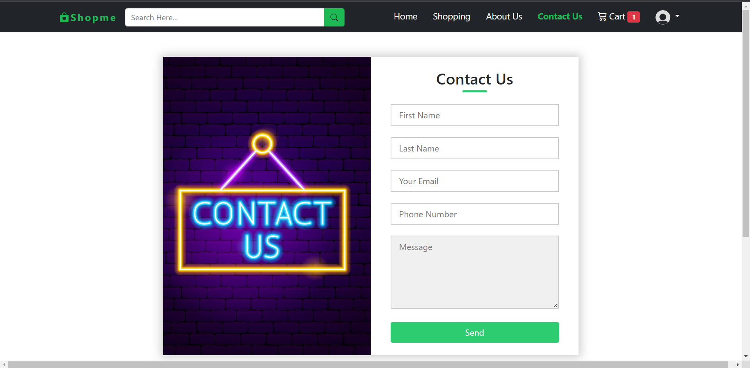

**5.1.2 ADMINISTRATOR:**

The administrator is the super user of this application. Only admin have access into this admin page. Admin may be the owner of the shop. The administrator has all the information about all the users and about all products.

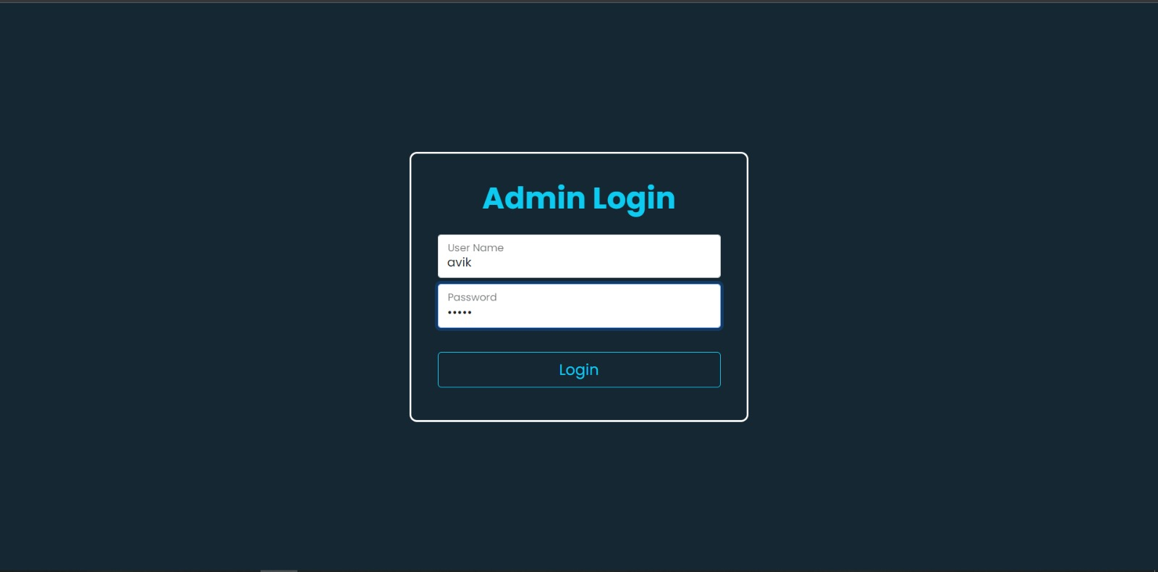

**This module is divided into different sub-modules.**

* User Table.
* User Search.
* Contact Us Table.
* Product Table.
* Add To Product.
* User Cart Table.
* User Order Table.

**User Table:** This table shows the total number of users that have created their account.

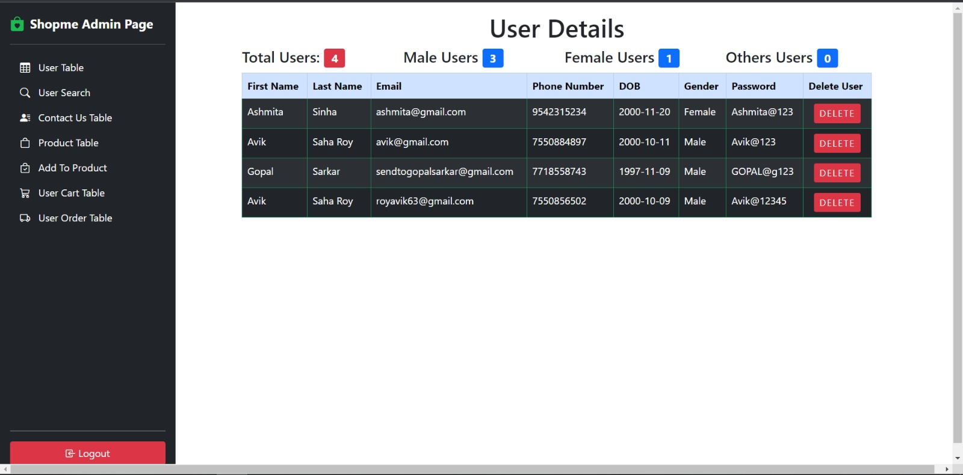

**User Search:**

This page shows that for Finding an User – you can either search by Email OR First Name, Last Name Search Either by their Phone Number.

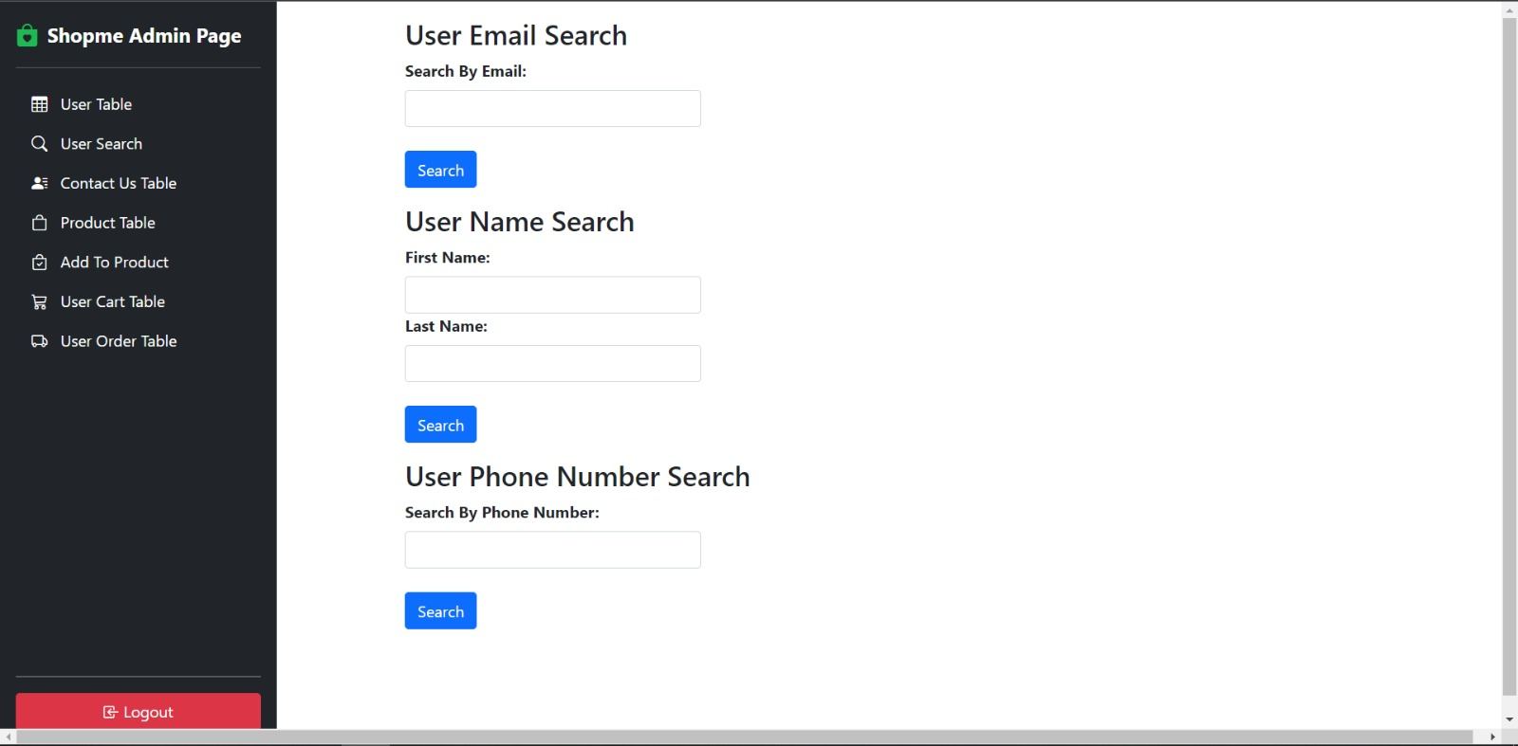

**Contact Us Table:**

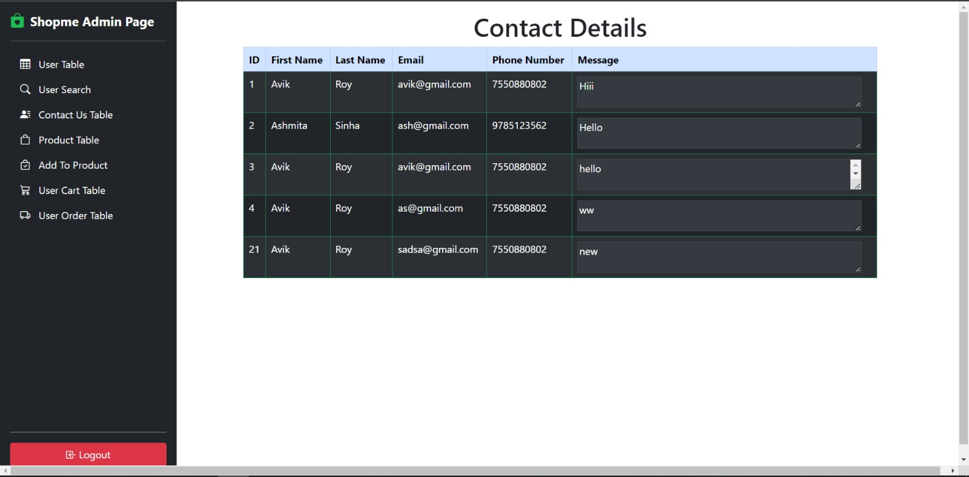

**Product Table:**

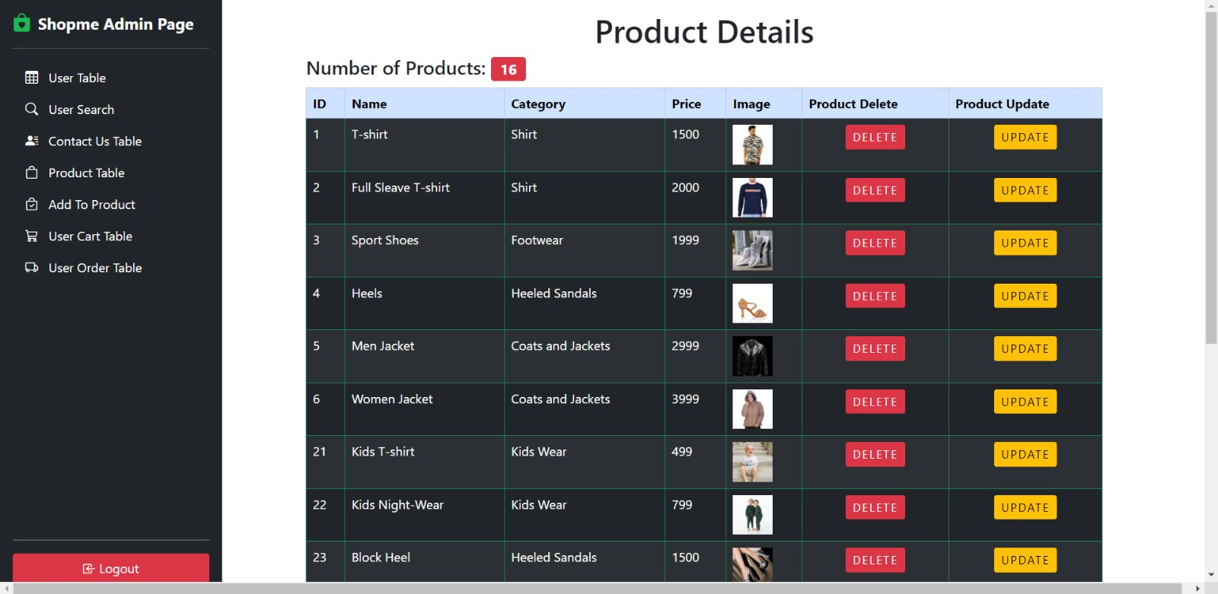

**Add To Products:**

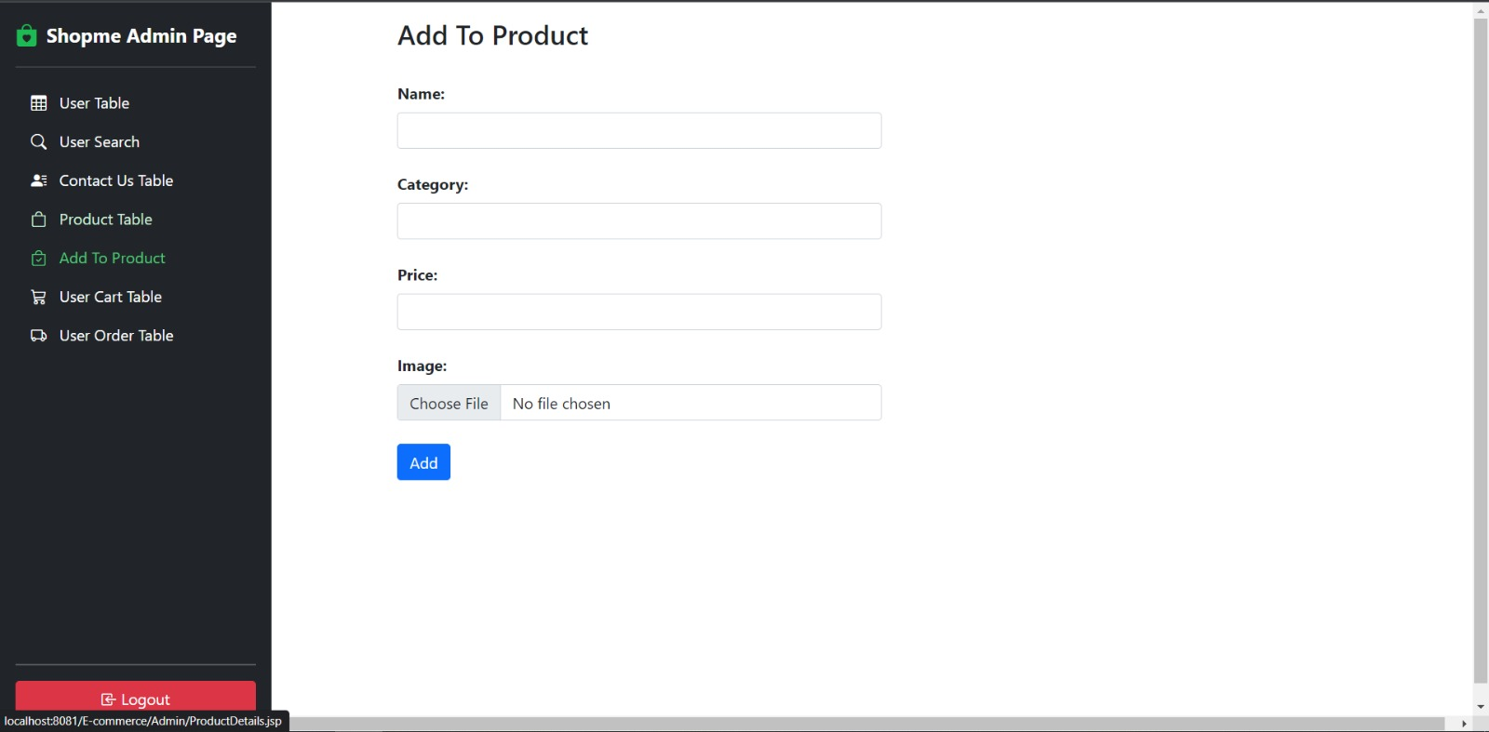

**User Cart Table:**

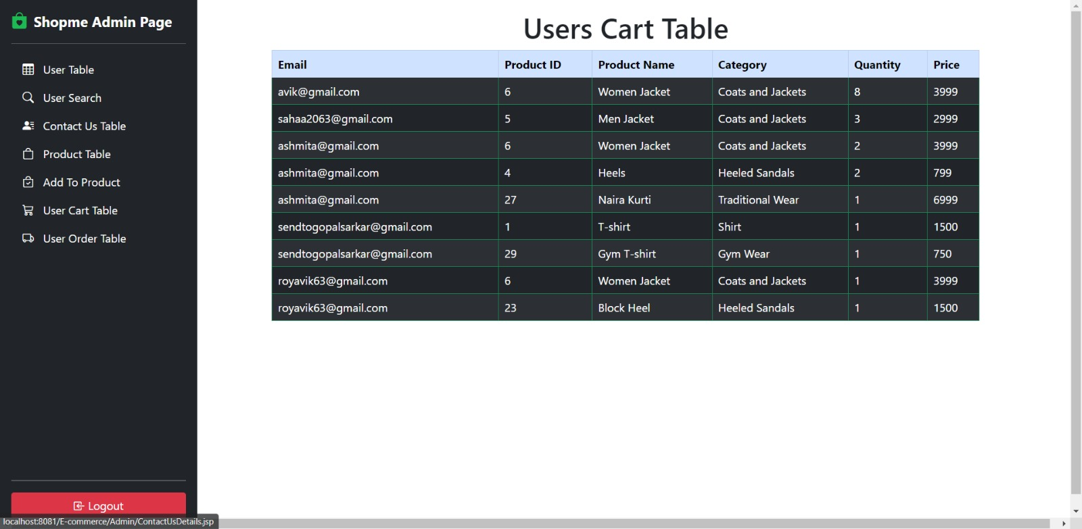

**Users Order Table:**

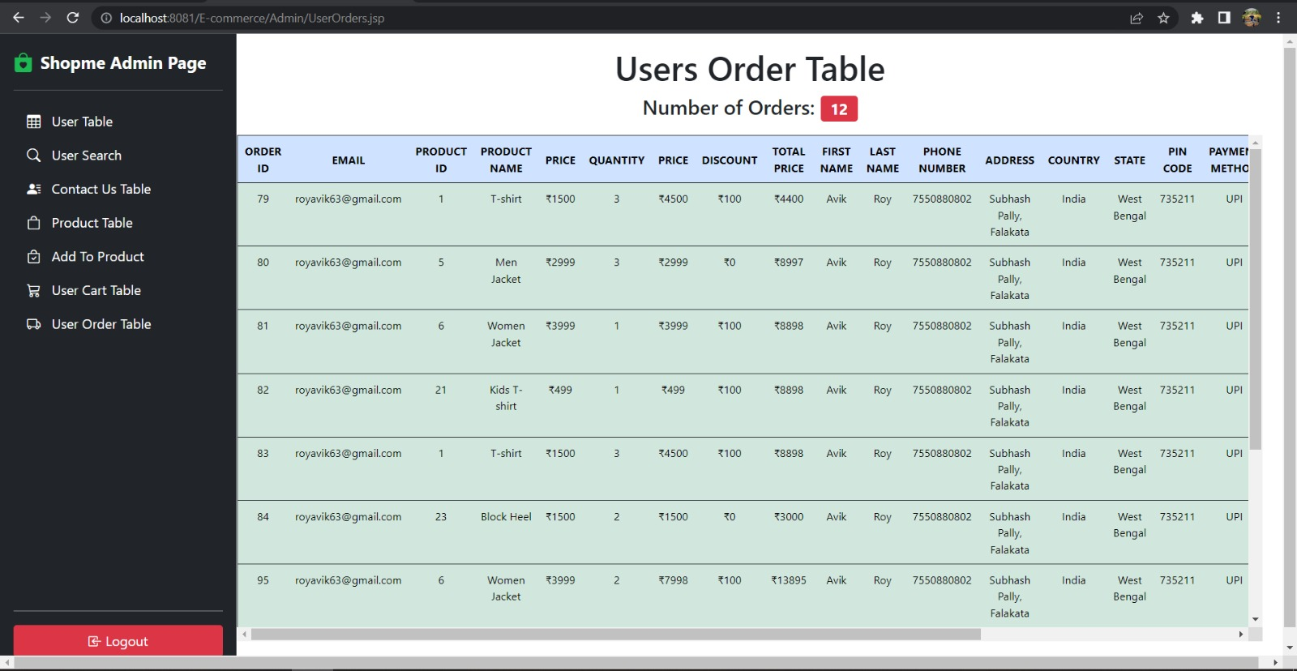

Online E-commerce System:

• Management Module: Used for managing the Clothes details.

• Order Module: Used for managing the details of Order

• Delivery Address Module: Used for managing the details of Delivery

Address

• Item Category Management Module: Used for managing the information

and details of the Item Category.

• Shopping Cart Module: Used for managing the Shopping Cart details

• Customer Module: Used for managing the Customer information